ASSIGNMENT – 09 (DBMS LAB)

* **PROBLEM:**

1. **Display unique jobs from emp table.**
2. **Display the name whose salary is more than 2850.**
3. **Display the employee name and department no whose employee number is 7566.**
4. **Display the name & salary of all employees whose salary is not in the range 1500 and 2850.**
5. **List the name of and salary of employees who earn more than 1500 and are in department 10**
6. **Display the name of employee who has joined in the year 1982.**
7. **Display the name and job title of all employees who do not have a manager.**
8. **Display the name, salary and commission of all employees who earn commission.**
9. **Display the names of all employees where third letter of their name is an A.**
10. **Display the name of all employees who have two 'L's in their name and are in department**

30 or their manager is 7782.

1. **Display the empno, ename, salary and salary increase by 15%.**
2. **Make a unique list of all jobs that are in department 30.**

* **PROGRAM:**

create table emp_091(emp_no number(38),emp_name varchar2(38),job varchar2(38),mgr number(38),hire_date date,sal number(38),comm number(6,2),dept_no number(38),primary key(emp_no),foreign key(dept_no) references dept_091(dept_no));

* **OUTPUT :**

Table created.

* **PROGRAM:**

describes emp_091;

* 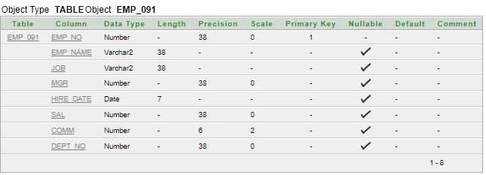**OUTPUT:**
* **PROGRAM:**

create table dept_091(dept_no number(38),d_name varchar2(38),loc varchar2(38),primary key(dept_no));

* **OUTPUT:**

Table created.

* **PROGRAM:**

describes dept_091;

* **OUTPUT:**

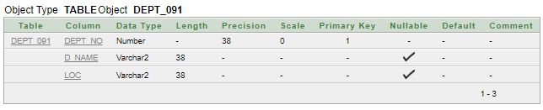

* **PROGRAM:**

**begin**

**insert into emp_091 values(7499,'ALLEN','SALESMAN',7698,'20-Feb-1981',1600,300,30); insert into emp_091 values(7521,'WARD','SALESMAN',7698,'22-Feb-1981',1250,500,30); insert into emp_091 values(7566,'JONES','MANAGER',7839,'05-Feb-1981',2975,0,20); insert into emp_091 values(7654,'MARTIN','SALESMAN',7698,'28-Sep-1981',1250,1400,30); insert into emp_091 values(7698,'BLAKE','MANAGER',7839,'01-May-1981',2850,0,30); insert into emp_091 values(7782,'CLARK','MANAGER',7839,'09-Jun-1981',2450,56.53,10); insert into emp_091 values(7788,'SCOTT','ANALYST',7566,'19-Apr-1987',3000,88.59,20); insert into emp_091 values(7839,'KING','PRESIDENT',0,'17-Nov-1981',5000,0,10);**

**insert into emp_091 values(7844,'TURNER','SALESMAN',7698,'08-Sep-1981',1500,0,30); insert into emp_091 values(7876,'ADAMS','CLERK',7788,'23-May-1987',1100,0,20); insert into emp_091 values(7900,'JAMES','CLERK',7698,'03-Dec-1981',950,0,30);**

**insert into emp_091 values(7902,'FORD','ANALYST',7566,'12-Dec-1981',3000,99.63,20); insert into emp_091 values(7934,'MILLER','CLERK',7782,'24-Jan-1982',1300,0,10);**

**end**

* **OUTPUT:**

Statement processed.

* **PROGRAM:**

select * from emp_091;

* 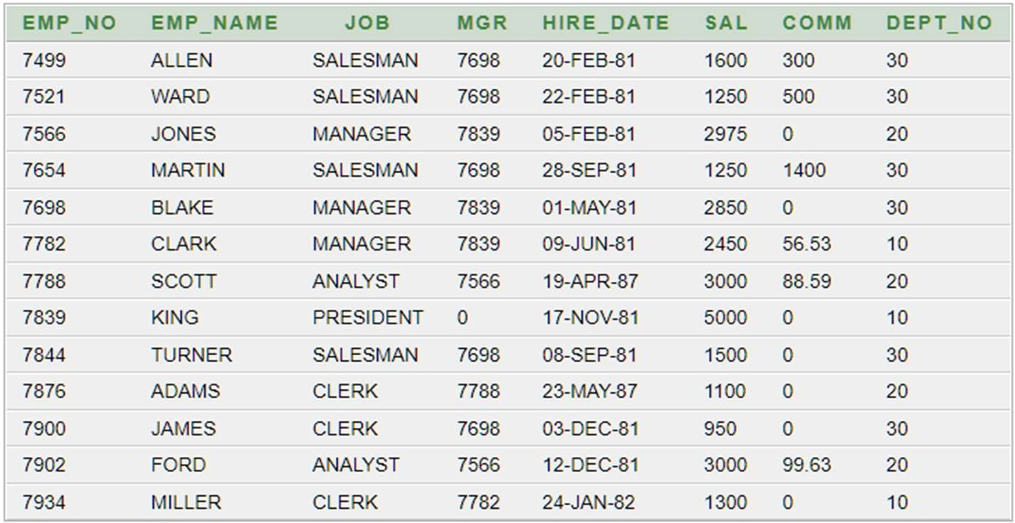**OUTPUT:**
* **PROGRAM:**

**begin**

**insert into dept_091 values(10,'ACCOUNTING','NEW YORK'); insert into dept_091 values(20,'RESEARCH','DALLAS');**

**insert into dept_091 values(30,'SALES','CHICAGO');**

**insert into dept_091 values(40,'OPERATIONS','BOSTON'); end**

* **OUTPUT:**

Statement processed.

* **PROGRAM:**

select * from dept_091;

* 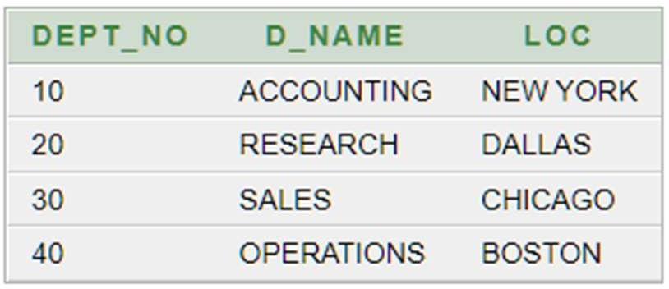**OUTPUT:**
* **PROGRAM:**

select distinct dept_no,job from emp_091;

* **OUTPUT:**

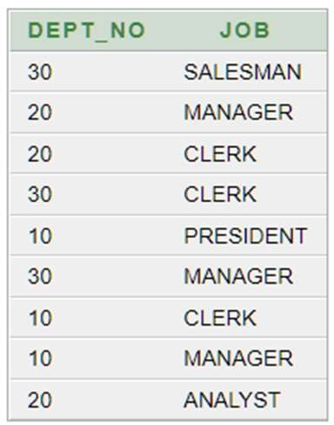

* **PROGRAM:**

select emp_name,sal from emp_091 where sal>2850;

* **OUTPUT:**
* **PROGRAM:** 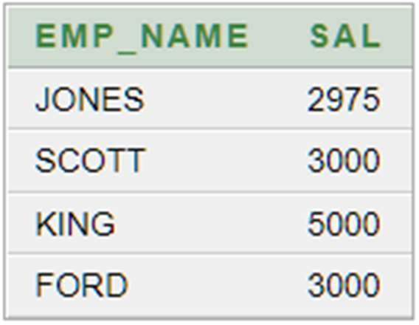

select emp_name,dept_no from emp_091 where emp_no=7566;

* **OUTPUT:**
* **PROGRAM:** 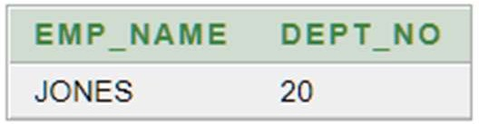

select emp_name,sal from emp_091 where sal not between 1500 and 2850;

* 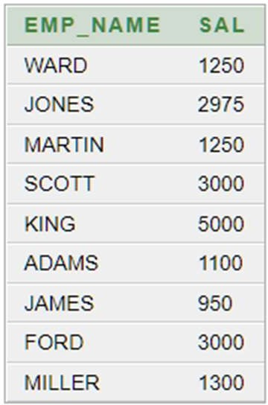**OUTPUT:**
* **PROGRAM:**

select distinct emp_name,sal,dept_no from emp_091 where sal>1500 and dept_no in (10,30);

* **OUTPUT:**
* **PROGRAM:** 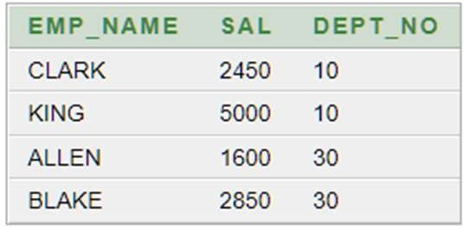

select * from emp_091 where to_char(hire_date,'YYYY') = 1982;

* **OUTPUT:**



* **PROGRAM:**

select emp_name,job from emp_091 where job !='MANAGER';

* 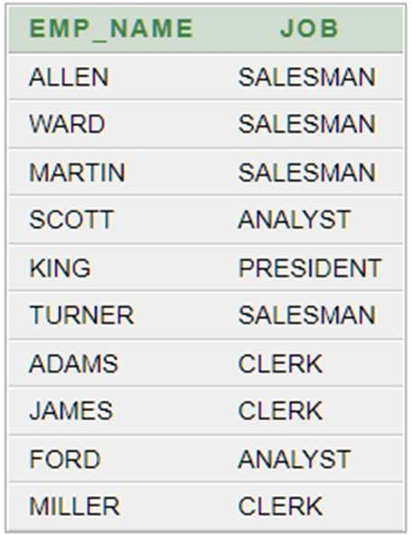**OUTPUT:**
* **PROGRAM:**

select emp_name,sal,comm from emp_091 where comm>0;

* **OUTPUT:**

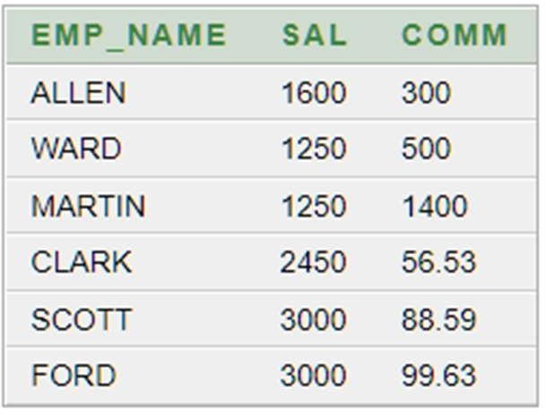

* **PROGRAM:**

select emp_name from emp_091 where emp_name like ' A%';

* 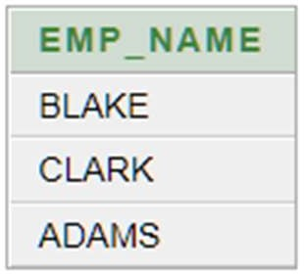**OUTPUT:**
* **PROGRAM:**

select * from emp_091 where emp_name like '%LL%' and dept_no=10 and mgr=7782;

* **OUTPUT:**
* **PROGRAM:**

select emp_no,emp_name,1.5*sal as salary from emp_091;

* 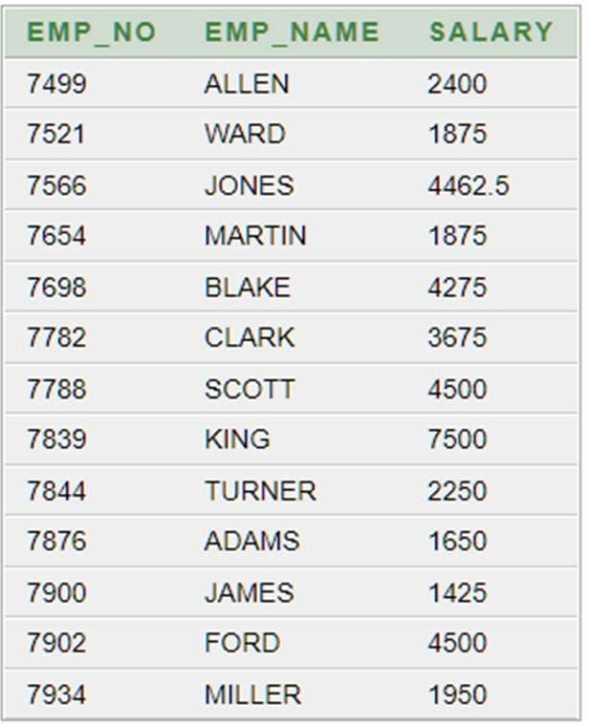**OUTPUT:**
* **PROGRAM:**

select job,dept_no from emp_091 where dept_no in 30;

* **OUTPUT:**

